Angular provides a robust testing framework, and there are several tools and libraries commonly used for unit testing in Angular applications. The main testing tools for Angular are:

****Jasmine:****

* + ****Description:**** Jasmine is a behavior-driven development (BDD) testing framework for JavaScript. It is the default testing framework used with Angular.
  + ****Key Features:****
    - Provides a clean and expressive syntax for writing tests.
    - Supports various matchers for expectations.
    - Can be extended with custom matchers.

****Karma:****

* + ****Description:**** Karma is a test runner for JavaScript that is widely used in the Angular ecosystem. It allows you to execute tests in various browsers.
  + ****Key Features:****
    - Integrates with Jasmine by default (though it supports other testing frameworks).
    - Provides a development server for running tests in real browsers.
    - Can watch files for changes and rerun tests automatically.

****Protractor:****

* + ****Description:**** Protractor is an end-to-end testing framework for Angular applications. While it's often associated with e2e testing, it can also be used for unit testing Angular components.
  + ****Key Features:****
    - Designed specifically for Angular applications.
    - Supports automatic waiting for Angular asynchronous operations.
    - Can interact with elements using Angular-specific locators.

****Angular Testing Utilities:****

* + ****Description:**** Angular itself provides a set of testing utilities that make it easier to test Angular components, services, and other features.
  + ****Key Features:****
    - **TestBed**: Used to configure and create instances of Angular testing modules.
    - **ComponentFixture**: Wraps a component for testing and provides access to the component's instance and the component's native element.

****Jest:****

* + ****Description:**** While Jasmine and Karma are commonly used in the Angular ecosystem, Jest is another popular testing framework that can be used for Angular applications.
  + ****Key Features:****
    - Zero configuration by default (but can be customized).
    - Provides a fast and parallel test runner.
    - Supports snapshot testing.

When setting up an Angular project, the default configuration includes Jasmine and Karma. You can use the Angular CLI to generate tests and run them using Karma. Additionally, you can customize your testing setup based on your project's requirements.

To use these tools effectively, it's essential to understand the concepts of unit testing, testing modules, services, components, and dealing with dependencies in an Angular context.

UNIT TESTING::

Angular provides a robust testing framework, and there are several tools and libraries commonly used for unit testing in Angular applications. The main testing tools for Angular are:

Jasmine:

Description: Jasmine is a behavior-driven development (BDD) testing framework for JavaScript. It is the default testing framework used with Angular.

Key Features:

Provides a clean and expressive syntax for writing tests.

Supports various matchers for expectations.

Can be extended with custom matchers.

Karma:

Description: Karma is a test runner for JavaScript that is widely used in the Angular ecosystem. It allows you to execute tests in various browsers.

Key Features:

Integrates with Jasmine by default (though it supports other testing frameworks).

Provides a development server for running tests in real browsers.

Can watch files for changes and rerun tests automatically.

Protractor:

Description: Protractor is an end-to-end testing framework for Angular applications. While it's often associated with e2e testing, it can also be used for unit testing Angular components.

Key Features:

Designed specifically for Angular applications.

Supports automatic waiting for Angular asynchronous operations.

Can interact with elements using Angular-specific locators.

Angular Testing Utilities:

Description: Angular itself provides a set of testing utilities that make it easier to test Angular components, services, and other features.

Key Features:

TestBed: Used to configure and create instances of Angular testing modules.

ComponentFixture: Wraps a component for testing and provides access to the component's instance and the component's native element.

Jest:

Description: While Jasmine and Karma are commonly used in the Angular ecosystem, Jest is another popular testing framework that can be used for Angular applications.

Key Features:

Zero configuration by default (but can be customized).

Provides a fast and parallel test runner.

Supports snapshot testing.

When setting up an Angular project, the default configuration includes Jasmine and Karma. You can use the Angular CLI to generate tests and run them using Karma. Additionally, you can customize your testing setup based on your project's requirements.

To use these tools effectively, it's essential to understand the concepts of unit testing, testing modules, services, components, and dealing with dependencies in an Angular context.

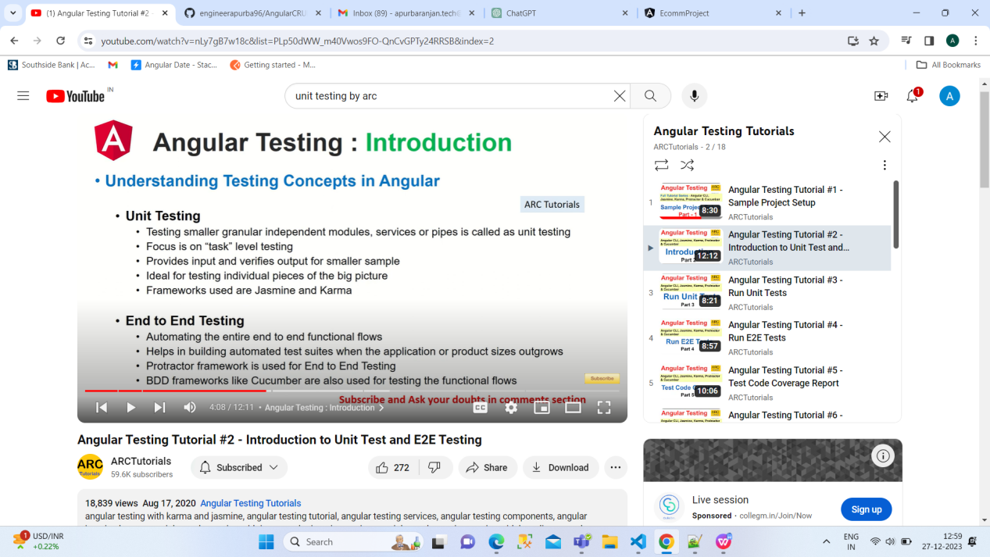

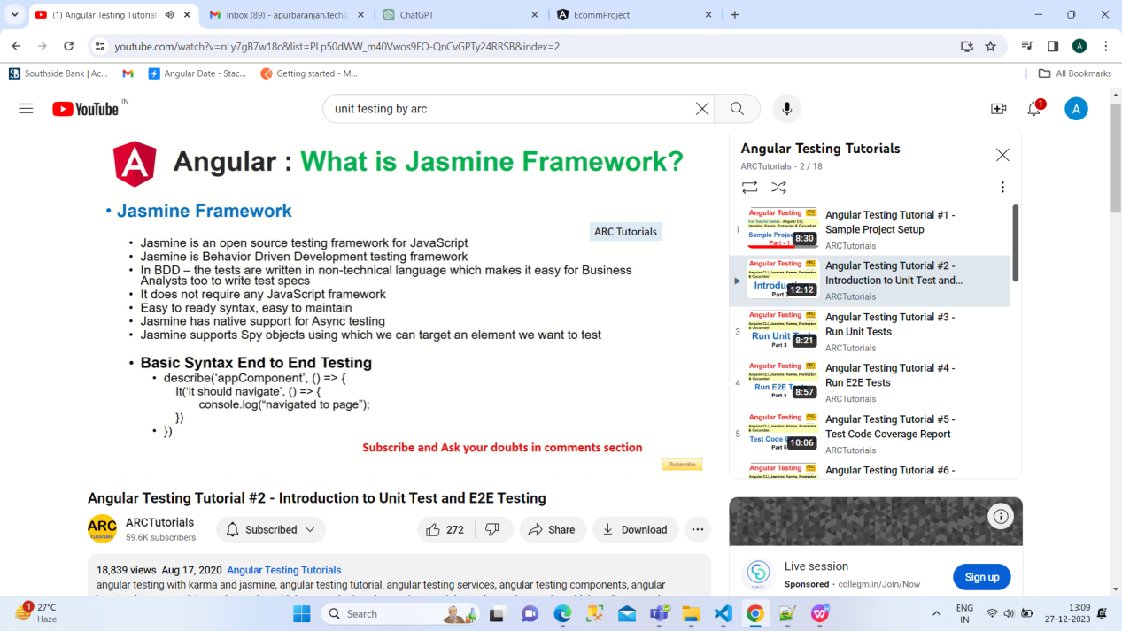

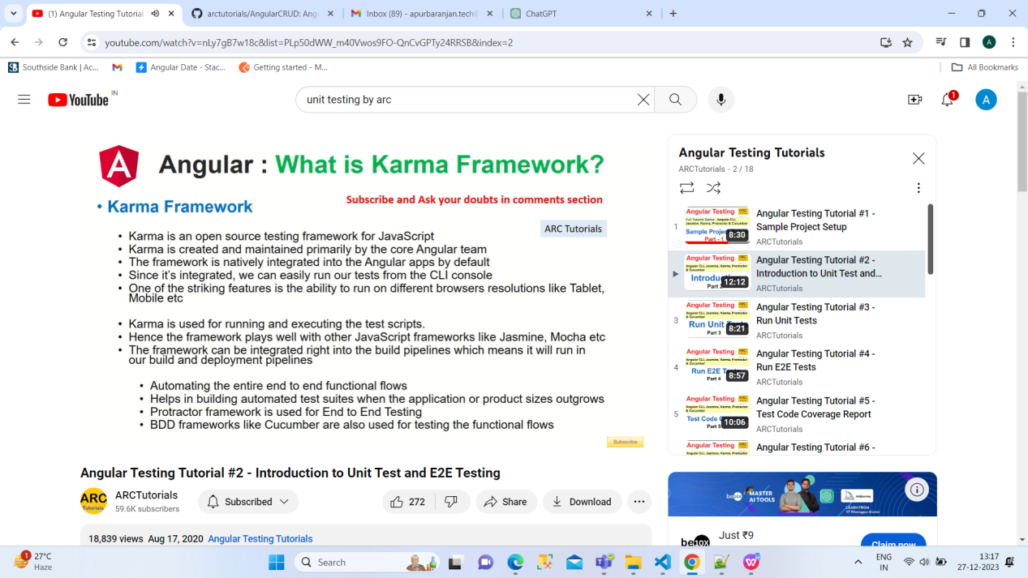

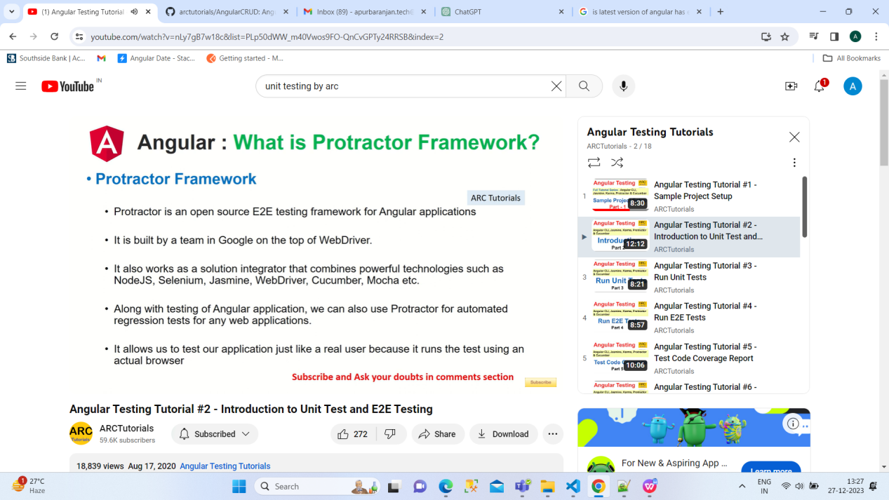

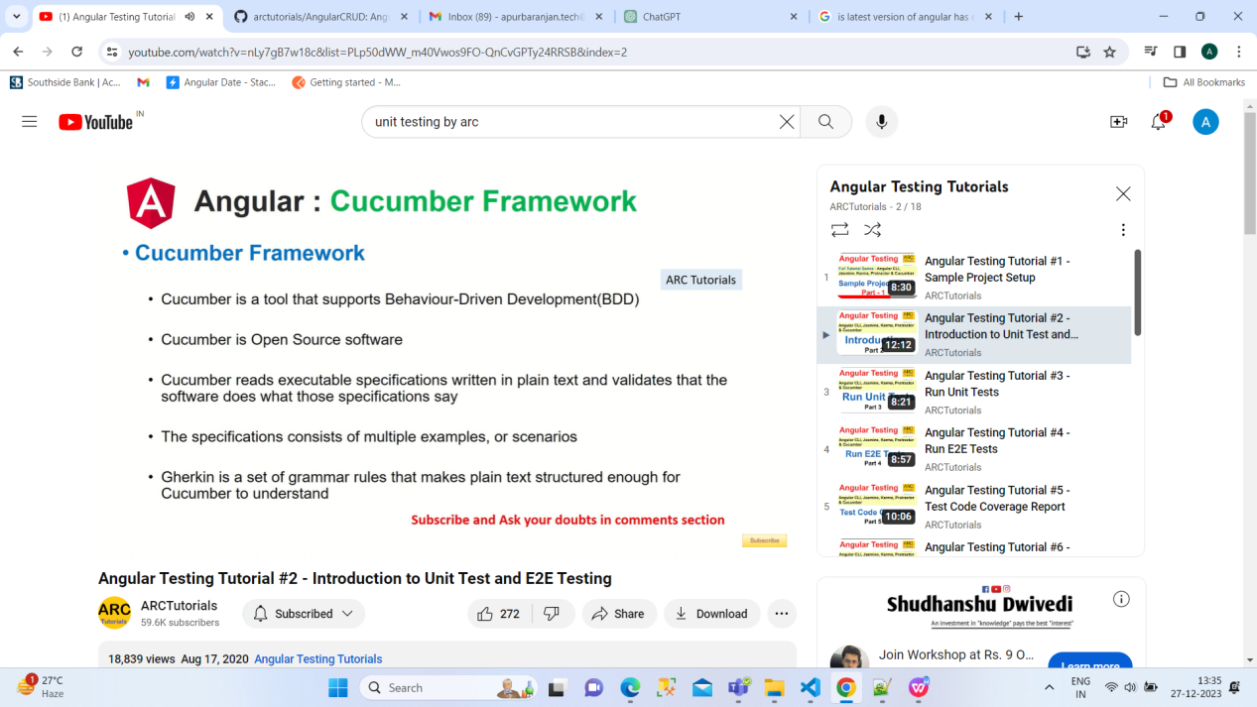

**Unit Test:**

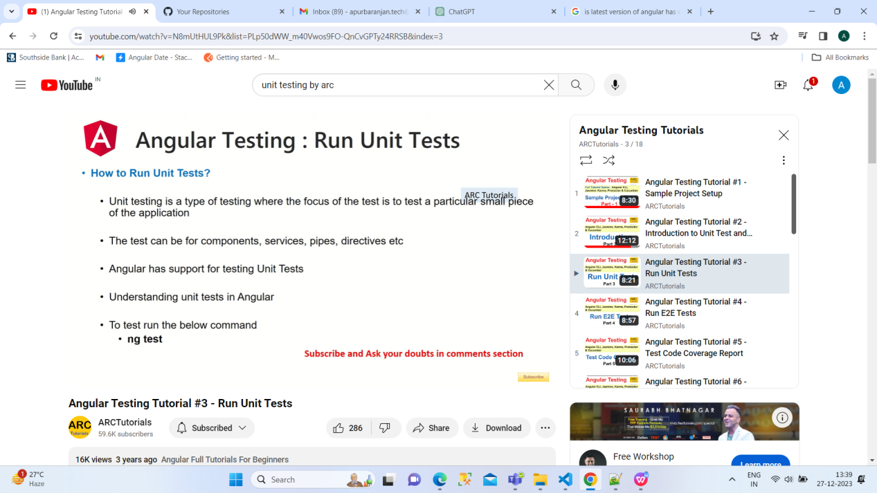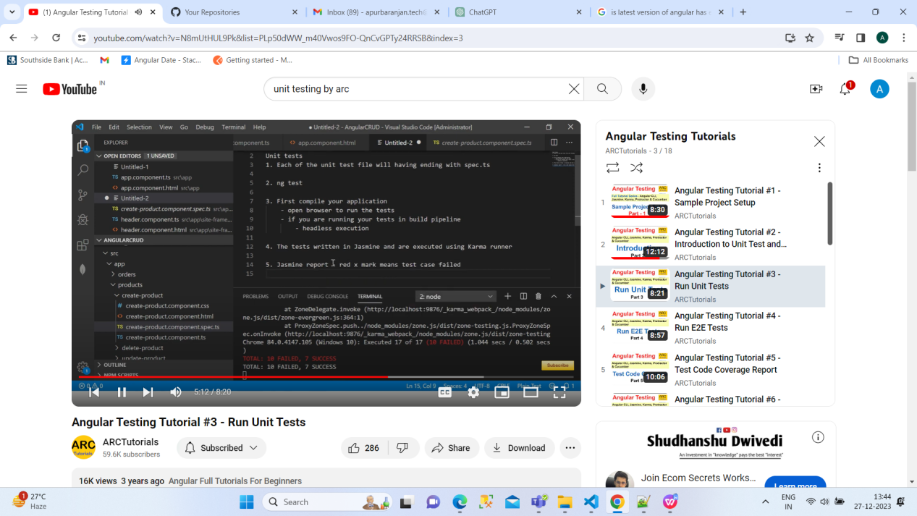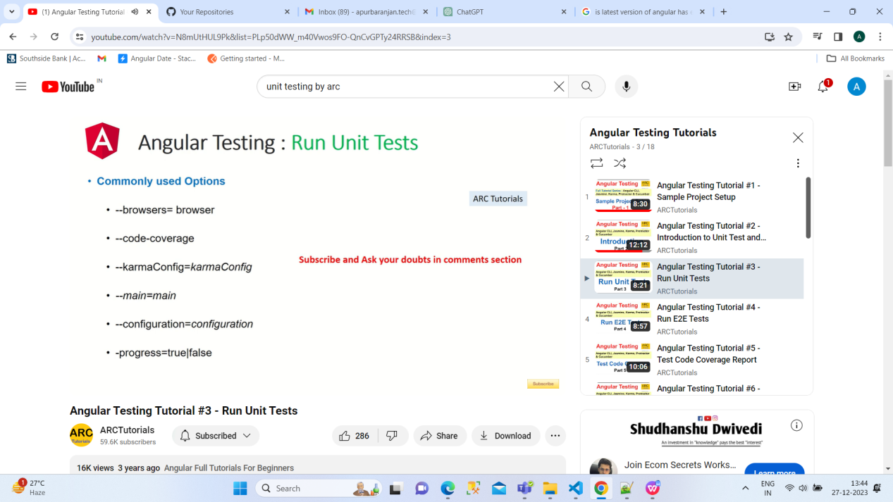

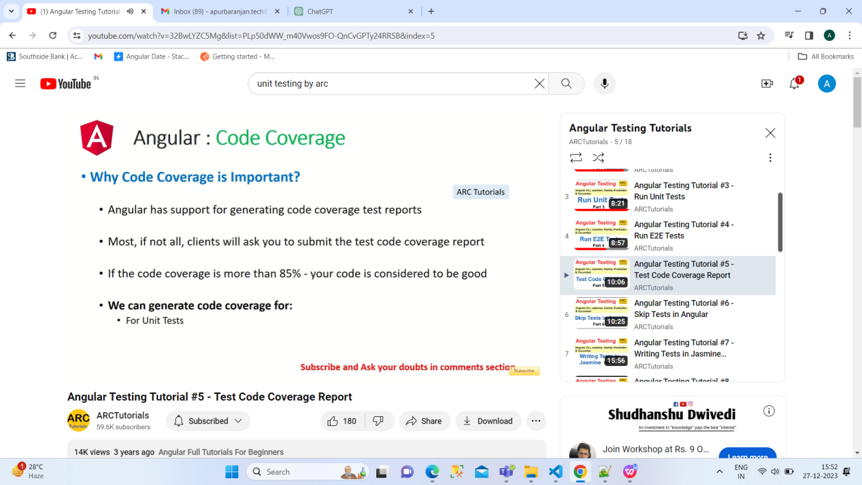

Code coverage in unit testing refers to the percentage of your codebase that is exercised by your tests. It helps you understand how much of your code is being tested and can be a valuable metric for assessing the thoroughness of your test suite. In Angular, code coverage is often measured using tools like Istanbul or the built-in coverage tools in popular testing frameworks.

Code coverage is for unit test only.

* ng test --code-coverage=true ---It means we need code coverage for current application

How to skip:

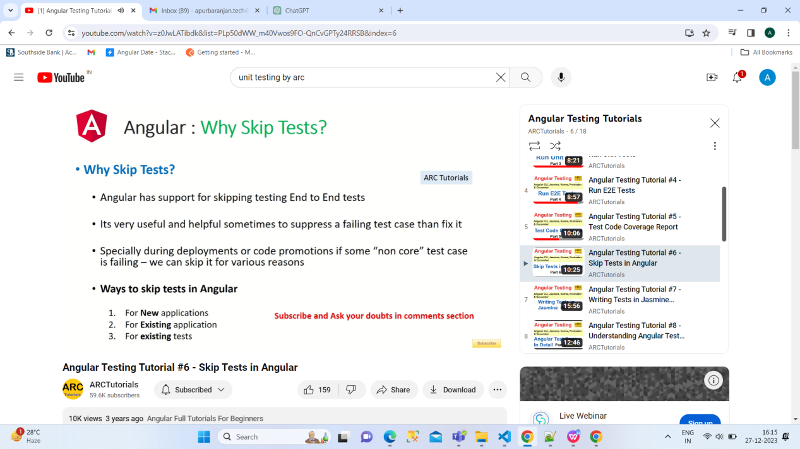

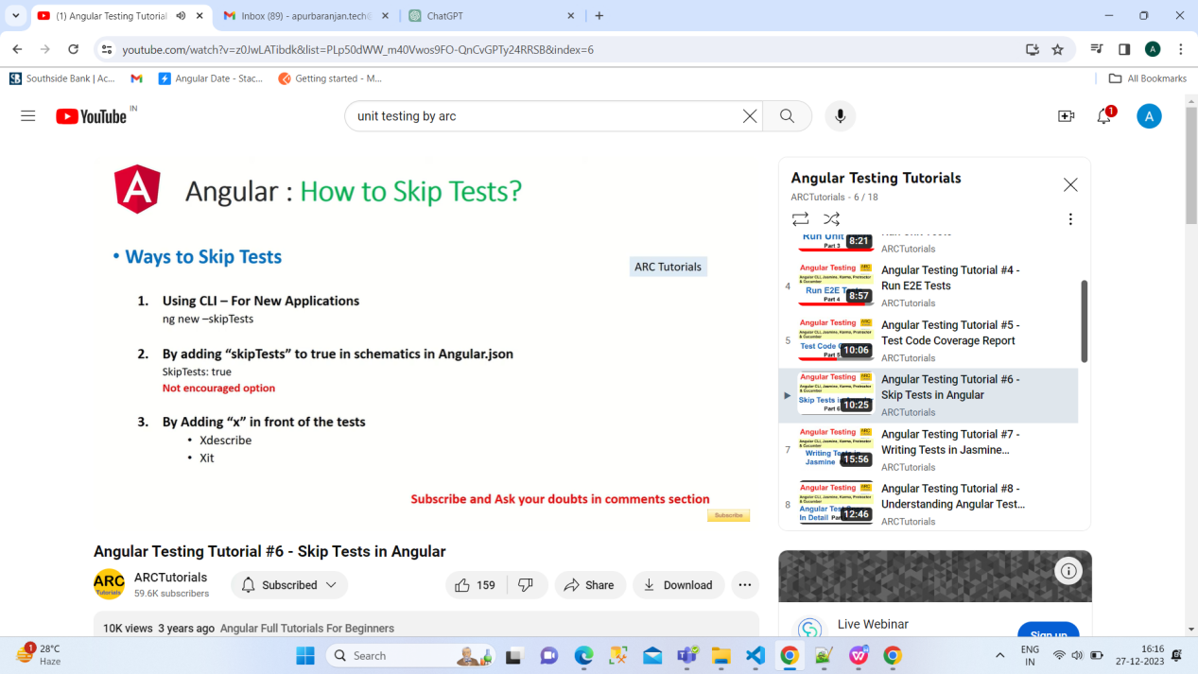

This for new

ng new projectname --skipTests

For old:

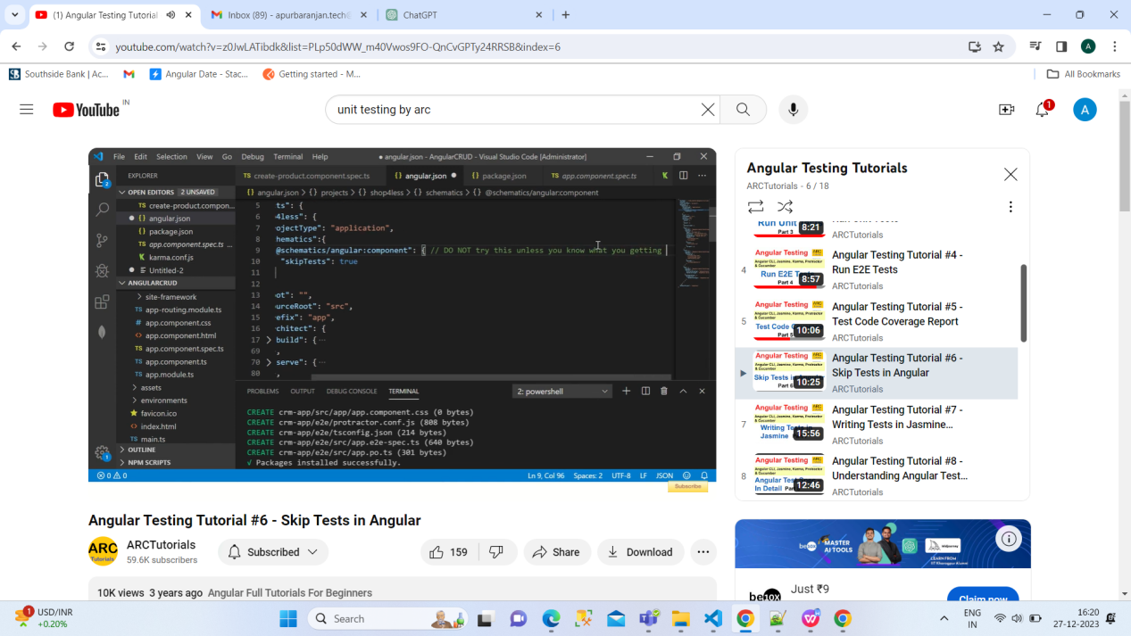

Basic Concept:

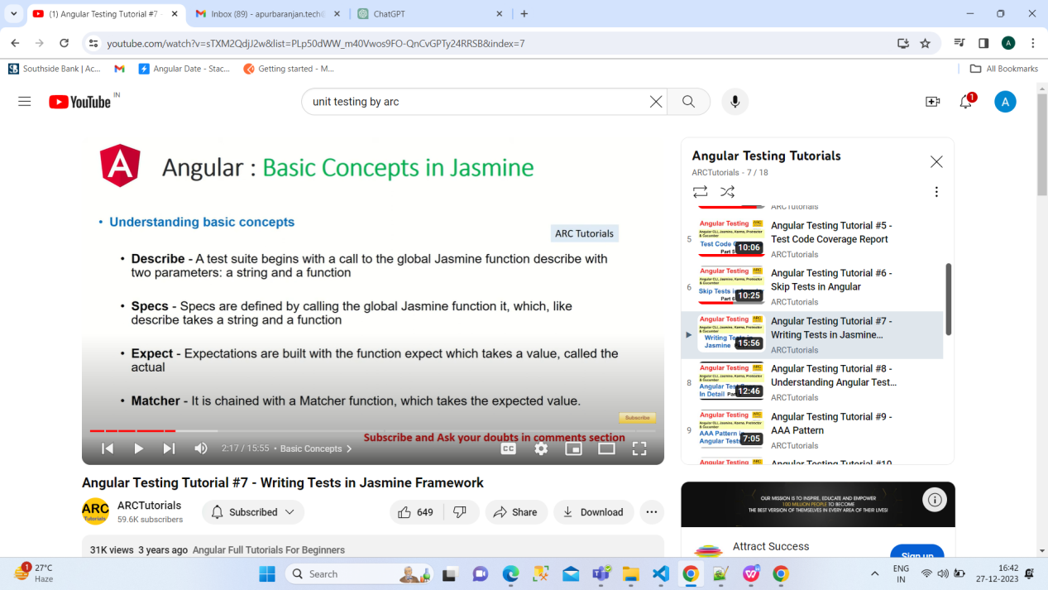

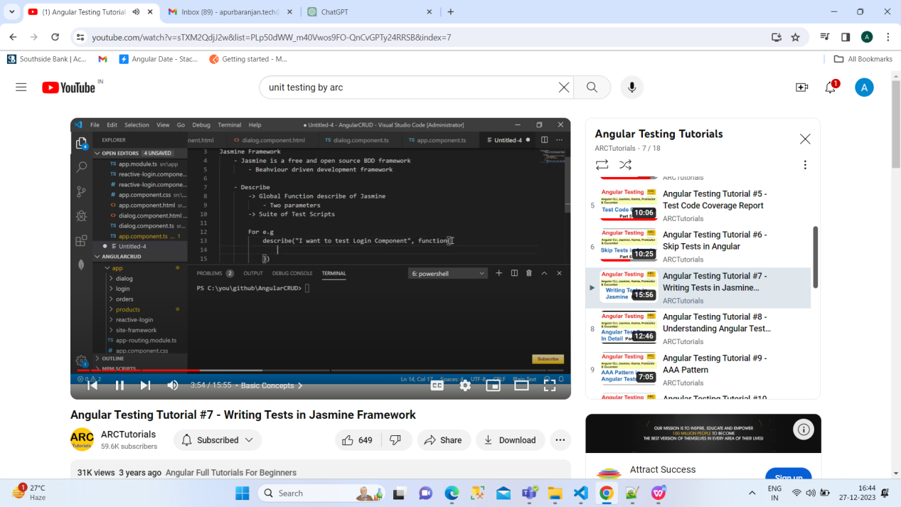

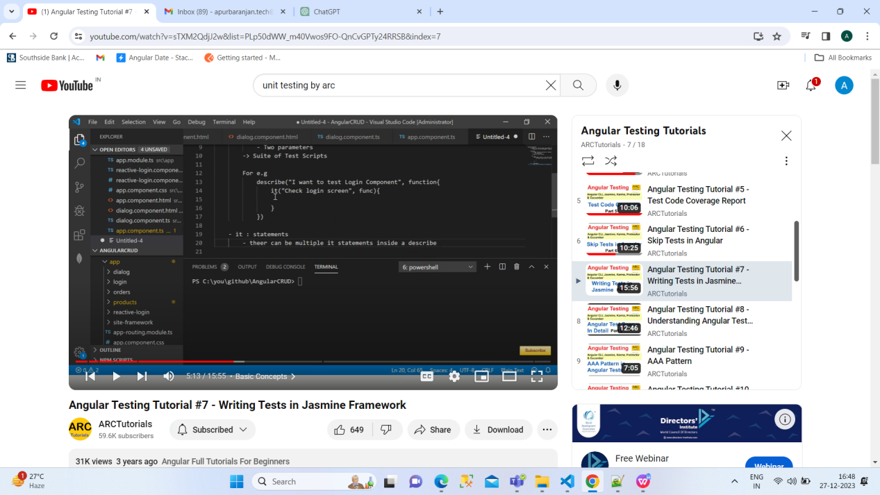

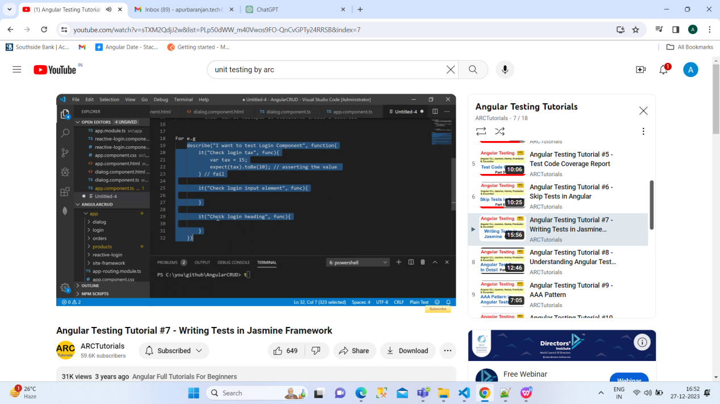

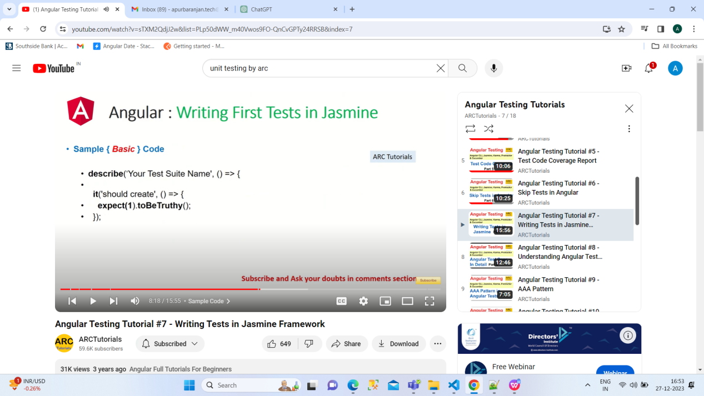

If we will put f in describe it meanse focused describe

Fdescribe

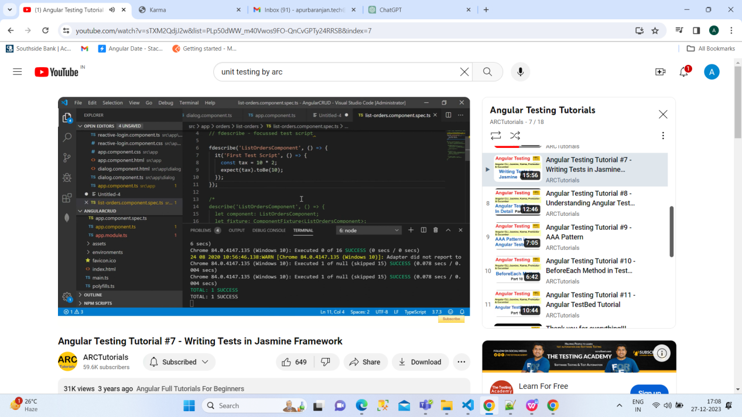

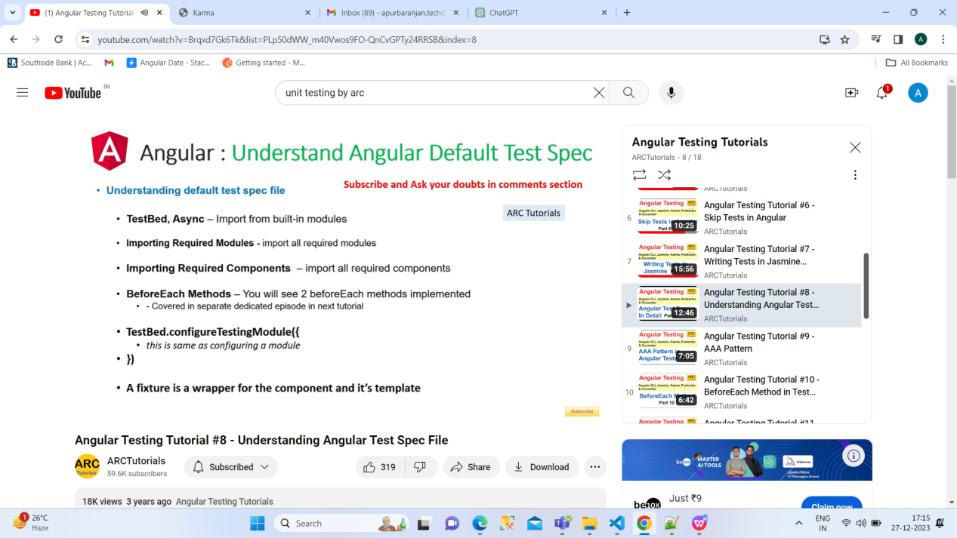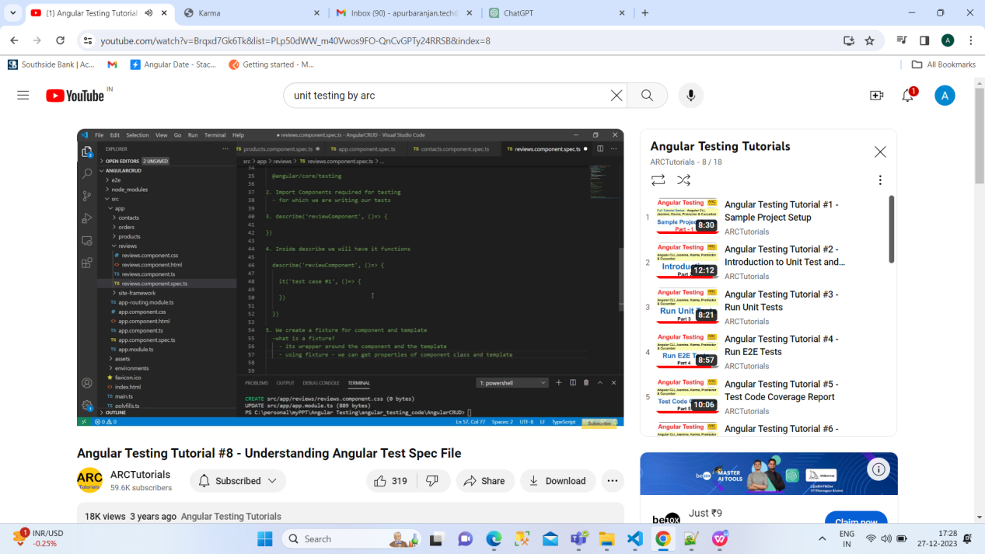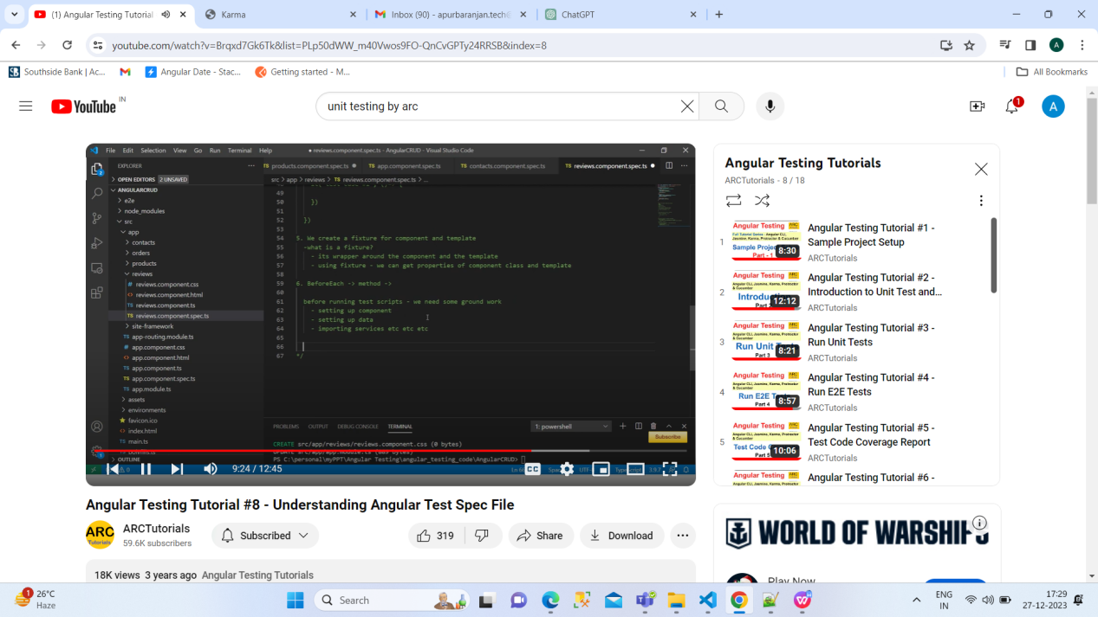

AAA:

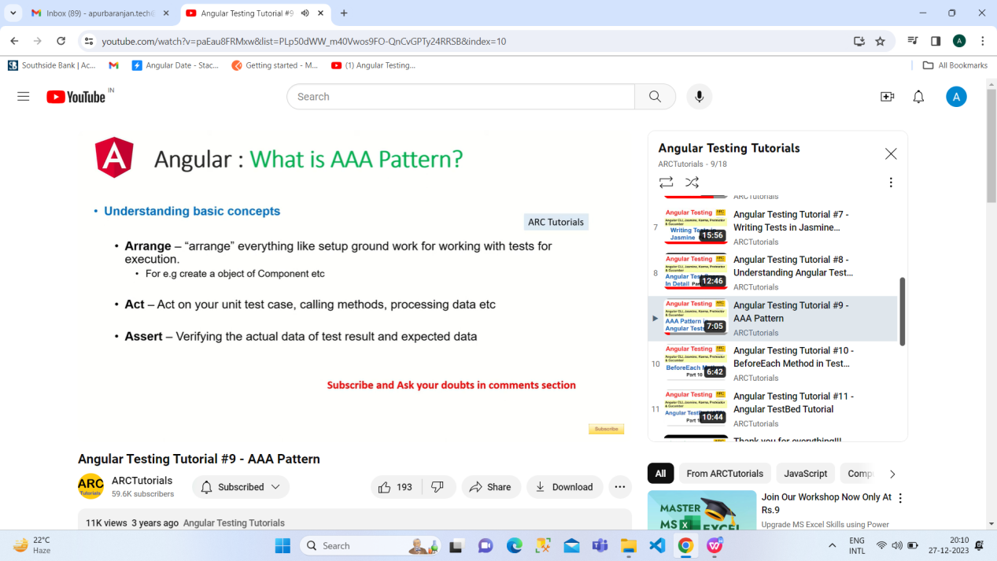

AAA stands for: Arrange, Act, Assert. This is a commonly taught structure for unit tests. This structure guides us in how to "arrange" our tests, and is generally considered to produce tests that are easier to maintain.

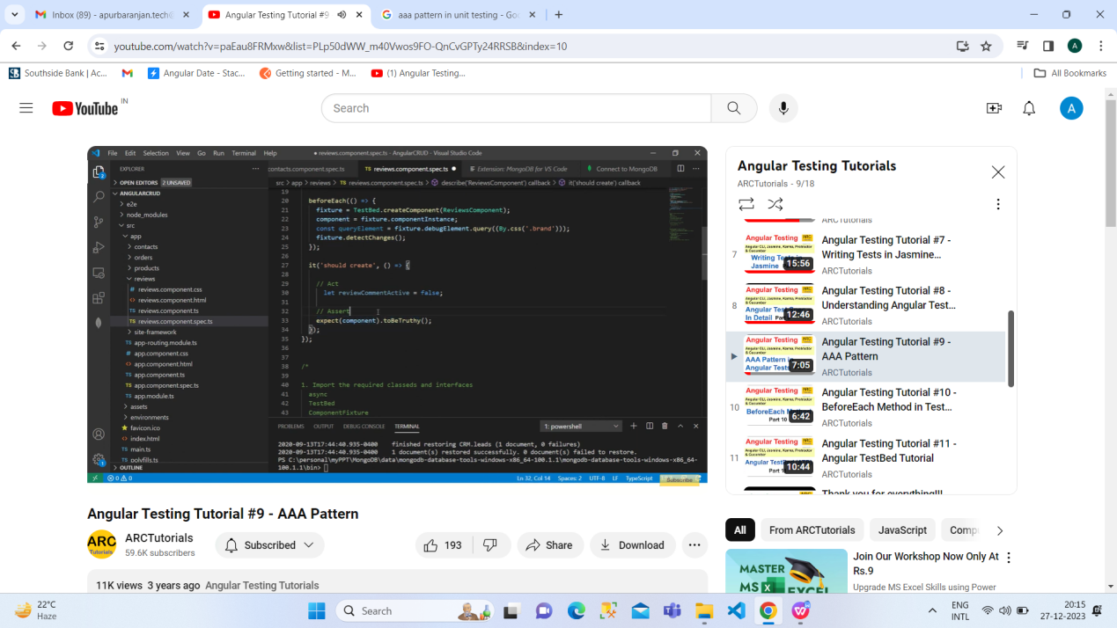

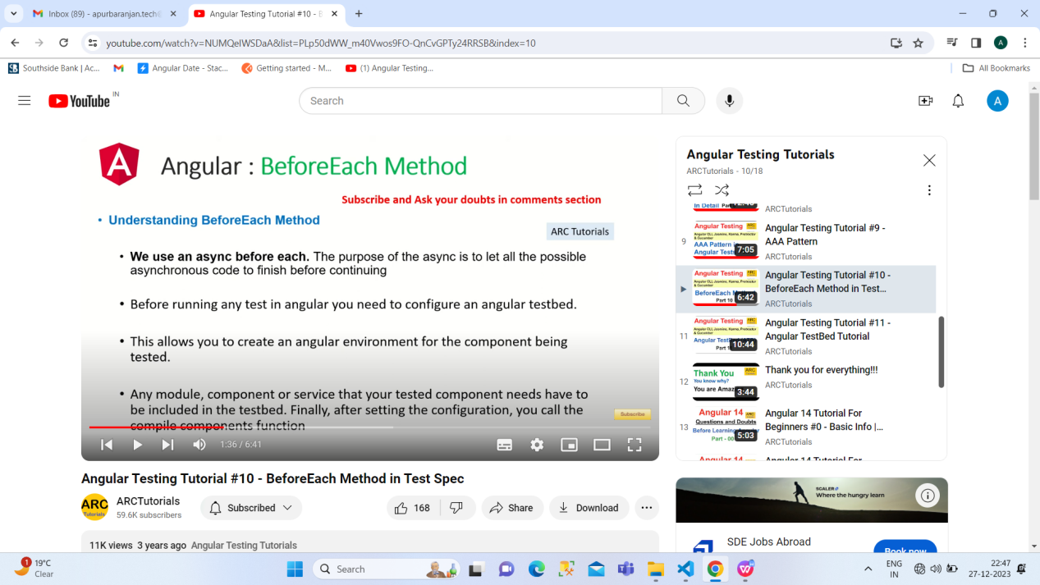

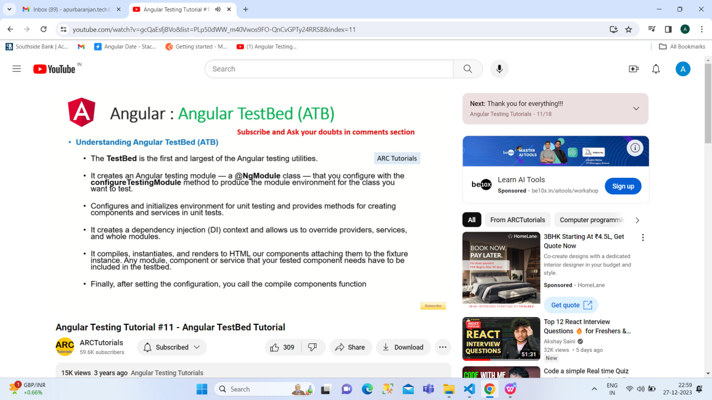

<div *ngIf="hero" class="name">{{hero.name}}</div>

    <ng-template [ngIf]="hero">

      <div class="name">{{hero.name}}</div>

    </ng-template>

First one is correct but 2 nd one is convert from 1st.\

const user = {

    name: 'Tyler',

    age: 27,

    greet: () => {

      console.log(`Hello, my name is ${this.name}`);

    }

  }

 user.greet();

;

Arrow function doesn’t support this.

const a={};

const b= JSON.stringify(a);

console.log(a===b);

False

const a={};

const b= {};

console.log(a==b);

False

const a={};

const b= {};

console.log(a===b);

False

const a={};

const b= a;

console.log(a==b)

True

The choice between Angular and React often depends on the specific requirements of a project, the expertise of the development team, and the preferences of the developers. Both Angular and React are popular JavaScript frameworks/libraries for building web applications, but they have different philosophies, features, and use cases. Here are some reasons why one might prefer Angular over React:

****Full-Featured Framework:****

* + Angular is a comprehensive and opinionated framework that comes with a lot of built-in features and tools, such as a powerful templating engine, dependency injection, and a complete set of tools for building large-scale applications. React, on the other hand, is more of a library focused on the view layer.

****Two-Way Data Binding:****

* + Angular uses two-way data binding, which means that changes in the model automatically update the view and vice versa. This can lead to less boilerplate code for managing the state and updating the UI.

****Dependency Injection:****

* + Angular has a built-in dependency injection system, which helps manage the components and their dependencies. This can make it easier to manage and test components.

****TypeScript Support:****

* + Angular is built with TypeScript in mind, and it's the primary language for Angular development. TypeScript is a superset of JavaScript that adds static typing, interfaces, and other features, which can help catch errors during development.

****Integrated Toolset:****

* + Angular provides a more integrated toolset out of the box. It includes tools like Angular CLI (Command Line Interface) for generating components, services, and more. React, being a library, often requires additional third-party tools and libraries for certain functionalities.

****Official Opinion on Architecture:****

* + Angular provides a more prescriptive approach to application architecture. It comes with a set of conventions and guidelines that can be beneficial, especially for large teams working on complex projects. React, being a library, allows more flexibility, which can be an advantage or a disadvantage depending on the project and team.

****Strong Enterprise Support:****

* + Angular is developed and maintained by Google, which can provide a sense of stability and long-term support for enterprise-level applications. React is developed and maintained by Facebook and has strong community support, but the backing of a large company like Google may be a factor in some enterprise decisions.

It's important to note that both Angular and React have their strengths and weaknesses, and the choice between them often comes down to the specific needs and preferences of the development team and the requirements of the project. Some developers may prefer the flexibility and simplicity of React, while others may appreciate the structure and features provided by Angular. Ultimately, both frameworks/libraries are capable of building powerful and scalable web applications.

Q1.how to check component,how much size it has taken in dom

Q2.how to check what modules take and how much size in prod bundle

Ans of q1 and q2: <https://www.youtube.com/watch?v=Lu-wzIbMTpo> <https://www.npmjs.com/package/webpack-bundle-analyzer>

CORS (Cross-Origin Resource Sharing) is a security feature implemented by web browsers to prevent web pages from making requests to a different domain than the one that served the web page. It is a browser security feature that protects users by restricting web pages from making requests to a different domain than the one that served the web page.

In the context of Angular applications, CORS errors typically occur when your Angular application, running in one domain (e.g., http://localhost:4200), tries to make a request to an API endpoint hosted on a different domain (e.g., http://api.example.com). Browsers enforce the Same-Origin Policy, and if the server hosting the API does not explicitly allow requests from your Angular application's domain, the browser will block the request and generate a CORS error.

The CORS error usually looks like this in the browser console: